**Assignment(28-12-2023)**

**DataBricks Introduction:**

* Databricks is a cloud-based platform that provides a unified analytics and data engineering workspace.
* It is built on top of Apache Spark, a powerful open-source, distributed computing system.
* Databricks simplifies big data processing and enables collaboration between data scientists, data engineers, and business analysts in a scalable and efficient manner.

Here are some key aspects and features of Databricks:

**Unified Platform:**

* Databricks offers a unified platform that integrates data processing, machine learning, and collaborative data exploration.
* It allows users to perform data engineering, data science, and business intelligence tasks seamlessly in one environment.

**Apache Spark Integration:**

* Databricks is closely tied to Apache Spark, an open-source distributed computing system.
* Spark provides fast and general-purpose cluster-computing capabilities, and Databricks leverages Spark to offer scalable data processing and analytics.

**Collaborative Workspace:**

* Databricks provides a collaborative workspace where data scientists, data engineers, and analysts can work together.
* The platform supports multiple programming languages such as Python, Scala, SQL, and R, making it flexible for different use cases.

**Notebooks:**

* Databricks uses notebooks, which are interactive documents that combine live code, visualizations, and narrative text.
* Notebooks facilitate collaboration by allowing users to share insights, code, and visualizations with others.

**Data Science and Machine Learning:**

* Databricks supports end-to-end machine learning workflows. It includes libraries and tools for building, training, and deploying machine learning models.
* The platform also enables the integration of popular machine learning frameworks like TensorFlow and scikit-learn.

**Cloud Data Platform of Azure**

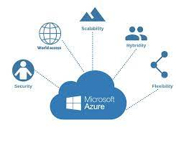

Azure, Microsoft's cloud computing platform, is a comprehensive suite of services that enables organizations to build, deploy, and manage applications and services through Microsoft's global network of data centers.

Azure provides a wide range of infrastructure and platform services, catering to various business needs.

**Azure Databricks Overview**

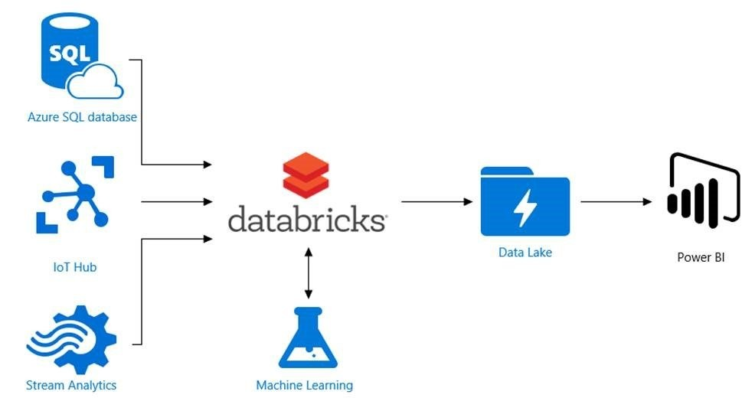

**Azure Databricks Components**

The platform consists of various components that work together to facilitate data processing, analysis, and machine learning. Here are key components of Azure Databricks:

**Workspace:**

* The Databricks Workspace is the central collaborative environment where users can create and manage notebooks, clusters, libraries, and dashboards.
* It provides a web-based interface for users to interact with and manage their Databricks resources.

**Notebooks:**

* Notebooks are interactive documents that combine live code, visualizations, and narrative text.
* Users can create and run notebooks for data exploration, analysis, and code development.
* Notebooks support multiple programming languages, including Python, Scala, SQL, and R.

**Clusters:**

* Clusters in Azure Databricks are computational resources that execute the code contained in notebooks.
* Users can create and configure clusters with different specifications based on their processing and memory requirements.
* Clusters are automatically managed by Databricks, providing scalability and resource optimization.

**Libraries:**

* Libraries are packages or dependencies that users can attach to clusters to extend functionality.
* Users can install and manage libraries to access additional tools, APIs, or custom code.

**Jobs:**

* Jobs in Databricks allow users to schedule and automate the execution of notebooks or JAR files.
* Users can specify the frequency and parameters for job runs, making it useful for recurring tasks and ETL (Extract, Transform, Load) processes.

**Tables and Views:**

* Databricks allows users to create and manage tables and views for structured data storage.
* Tables can be based on various data sources, including Delta Lake, Parquet, JSON, and more.

**Data Import and Export:**

Azure Databricks supports various data import and export options, including integration with Azure Data Factory, Azure Data Lake Storage, and Azure SQL Data Warehouse.

**Data Exploration and Visualization:**

* Databricks provides tools for data exploration and visualization, allowing users to create interactive dashboards and reports.
* It supports integration with popular visualization libraries like Matplotlib and Seaborn.

**Machine Learning Libraries and Tools:**

* Azure Databricks includes machine learning libraries and tools for building, training, and deploying machine learning models.
* It integrates with Azure Machine Learning for advanced machine learning workflows.

**Security and Authentication:**

Databricks provides security features such as access controls, encryption, and integration with Azure Active Directory for authentication.

**Workspace API:**

The Databricks REST API allows users to automate and programmatically manage Databricks resources using HTTP requests.

.